

Requirement & Design Specification
Local Cultural Experience & Shopping Booking Platform
Version: 1.0

– DaNang, May 2026 –

Record of Changes
Version | Date | A*  M, D | In charge | Change Description
V1.0 | 24/5 | A | NganVM | Added Introduction, Scope
 | 31/5 | A | NhatTD
 | 7/6 | A | NganVM | Update use case
*A - Added M - Modified D - Deleted

Contents
Record of Changes 2
I. Overview 4
1. User Requirements 4
1.1 Actors 4
1.2 Use Cases 4
2. Overall Functionalities 5
2.1 Screens Flow 5
2.2 Screen Descriptions 5
2.3 Screen Authorization 5
2.4 Non-UI Functions 6
3. System High Level Design 6
3.1 Database Design 6
3.2 Code Packages 7
II. Requirement Specifications 8
1. <<Feature Name>> 8
1.1 <<UseCaseCode_UC Name>> 8
2. Common Functions 11
2.1 UC-2_Login System 11
3. Patron Feature 12
3.1 UC-5_Order a Meal 12
3.2 UC-6_Register for Payroll Deduction 13
III. Design Specifications 14
1. <<Feature Name>> 14
1.1 <<SubFeature Name>> 14
1.2 System Access 15
IV. Appendix 19
1. Assumptions & Dependencies 19
2. Limitations & Exclusions 19
3. Business Rules 19
4. .. 19

I. Overview
Inroduction:
This document is the Requirement & Design Specification (RDS) for the Local Cultural Experience & Shopping Booking Platform - a web-based application that digitizes the reservation process for cultural experience workshops (pottery, cooking, traditional crafts, etc.) and the purchase of handcrafted physical products from local artisan studios.
The system is developed by a team of 5 members over an 8-week development cycle. Its primary goal is to create a seamless digital bridge connecting artisan studios (Hosts) with travelers and customers (Tourists), while supporting day-to-day operations through two additional internal roles: Tour Guide and Admin.
The platform serves as a one-stop solution covering the full journey - from discovery and booking to payment, check-in, and post-experience review.

Scope:
The scope of this project covers the design and development of a full-stack web application consisting of the following functional areas:
IN SCOPE
• Authentication & Authorization: Registration and login for all 4 roles (Admin, Host, Tour Guide, Tourist) secured with JWT.
• Platform Data Management: CRUD operations for Workshops and physical Products (by Host); account approval and locking (by Admin).
• Booking Flow: Workshop search and discovery (by name, price, and map location); timeslot management; calendar-based seat selection; smart slot-locking mechanism to prevent overbooking.
• E-Commerce Flow: Shopping cart (stored in browser LocalStorage); checkout form with delivery address input and fixed shipping fee of 30,000 VND; order status management by Host.
• Payment & E-Ticket: Online payment integration with VNPay or MoMo (Sandbox environment); unique QR code generation per booking; automated confirmation email with invoice and QR code.
• Operations & Analytics: Tour Guide assignment to timeslots; QR code check-in (mobile-first interface); post-experience review and photo upload; revenue dashboard for Admin (system-wide) and Host (individual).

OUT OF SCOPE
• Native iOS/Android mobile applications (web-responsive only).
• Cash payment or any payment gateway other than VNPay/MoMo.
• Integration with external ERP or accounting systems.
• Automated refund processing upon booking cancellation.

1. User Requirements

1.1 Actors
This part gives the description of system actors, you can follow the table form as below]
# | Actor | Description
1 | Admin | System administrator. Approves newly registered workshops (Hosts); Views total revenue statistics.
2 | Host (Workshop Owner / Artisan) | Uploads workshops and sets up timeslots; Sells physical products; Updates order status; Creates accounts and assigns schedules for Tour Guides.
3 | Tour Guide | Employee of the workshop. Logs in to view assigned schedules, check customer lists, scan QR codes for check-in, and update trip progress (Start/End).
4 | Tourist (Customer) | Searches and books tickets; Adds products to cart; Makes online payments; Receives e-tickets (QR Codes); Writes reviews.

1.2 Use Cases
[A use case (UC) describes a sequence of interactions between a system and an external actor that results in the actor being able to achieve some outcome of value. The names of use cases are always written in the form of a verb followed by an object. Select strong, descriptive names to make it evident from the name that the use case will deliver something valuable for some user]

a. Diagram(s)
[Provide the UC diagram(s) to show the actor-UCs and UC-UC relationships like the sample below. You can have multiple UC diagrams for the system]
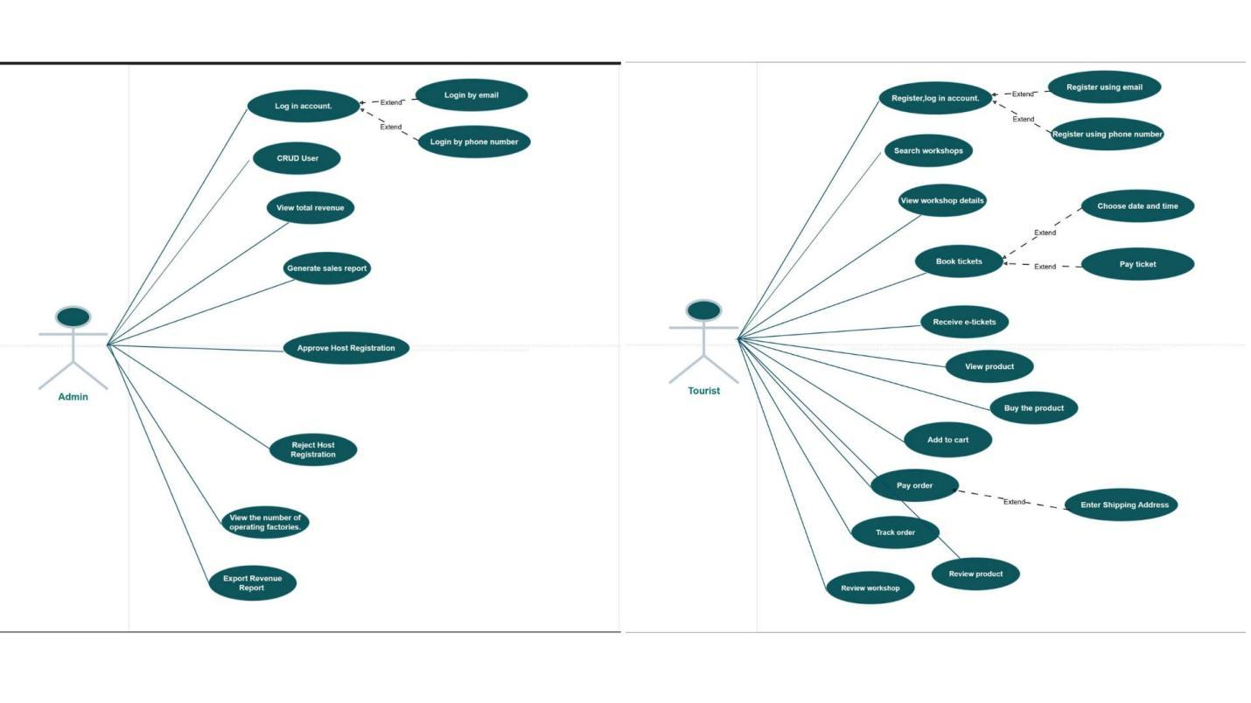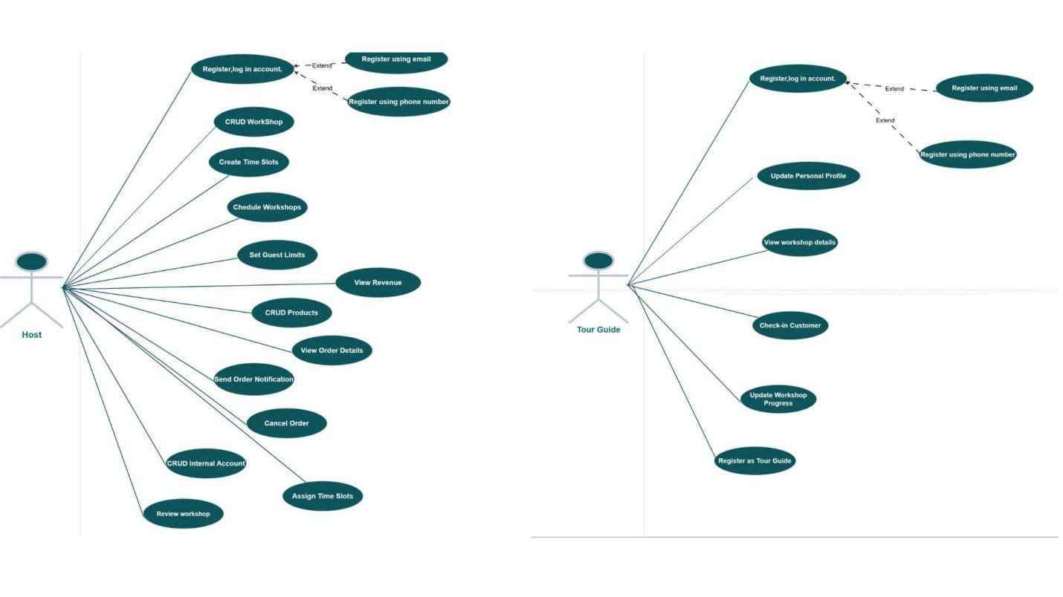

b. Descriptions
This part describes the use cases, you can follow the table form as below]
ID | Feature | Use Case | Use Case Description
01 | Authentication | Login Account | User logs into the system using email or phone number.
02 | Authentication | Register Account | User registers a new account using email or phone number.
03 | User Management | CRUD User | Admin creates, views, updates, and deletes user accounts.
04 | Host Management | Approve Host Registration | Admin approves a host registration request.
05 | Host Management | Reject Host Registration | Admin rejects a host registration request.
06 | Revenue Management | View Total Revenue | Admin views the total revenue of the platform.
07 | Revenue Management | Generate Sales Report | Admin generates sales and revenue reports.
08 | Revenue Management | Export Revenue Report | Admin exports revenue reports for further analysis.
09 | Statistics Management | View Operating Statistics | Admin monitors operational statistics and system performance.
10 | Workshop Search | Search Workshops | Tourist searches for available workshops.
11 | Workshop Information | View Workshop Details | Tourist views detailed information about a workshop.
12 | Ticket Booking | Book Tickets | Tourist books tickets for a selected workshop.
13 | Ticket Booking | Choose Date and Time | Tourist selects the preferred workshop date and time.
14 | Payment | Pay Ticket | Tourist pays for workshop tickets.
15 | Ticket Management | Receive E-Tickets | Tourist receives electronic tickets after successful payment.
16 | Product Catalog | View Products | Tourist browses available products.
17 | Shopping Cart | Add to Cart | Tourist adds products to the shopping cart.
18 | Shopping | Buy Product | Tourist purchases a product.
19 | Order Management | Enter Shipping Address | Tourist provides a shipping address for product delivery.
20 | Payment | Pay Order | Tourist completes payment for an order.
21 | Order Tracking | Track Order | Tourist tracks the status of an order.
22 | Review Management | Review Workshop | Tourist submits a review for a workshop.
23 | Review Management | Review Product | Tourist submits a review for a purchased product.
24 | Workshop Management | CRUD Workshop | Host creates, views, updates, and deletes workshops.
25 | Schedule Management | Create Time Slots | Host creates available time slots for workshops.
26 | Schedule Management | Schedule Workshops | Host schedules workshops.
27 | Capacity Managemen | Set Guest Limits | Host sets the maximum number of participants.
28 | Revenue Management | View Revenue | Host views revenue generated from workshops and products.
29 | Product Management | CRUD Products | Host manages products by creating, viewing, updating, and deleting them.
30 | Order Management | View Order Details | Host views detailed information about customer orders.
31 | Notification Management | Send Order Notification | Host sends notifications regarding order updates.
32 | Order Management | Cancel Order | Host cancels an order when necessary.
33 | Profile Management | Update Personal Profile | Tour Guide updates personal profile information.
34 | Workshop Information | View Workshop Details | Tour Guide views assigned workshop details.
35 | Attendance Management | Check-in Customers | Tour Guide checks in customers upon arrival.
36 | Workshop Progress Management | Update Workshop Progress | Tour Guide updates the progress/status of an ongoing workshop.

2. Overall Functionalities

2.1 Screens Flow

[This part shows the system screens and the relationship among screens. You can draw the Screens Flow for the system in the form of diagram as below. Please note that beside the normal flat screen, we might have the oval notation for pop-up screen (Import Order) or a screen with multiple information tab (Order Details), etc. You may also use text or background format for different visuality purpose]
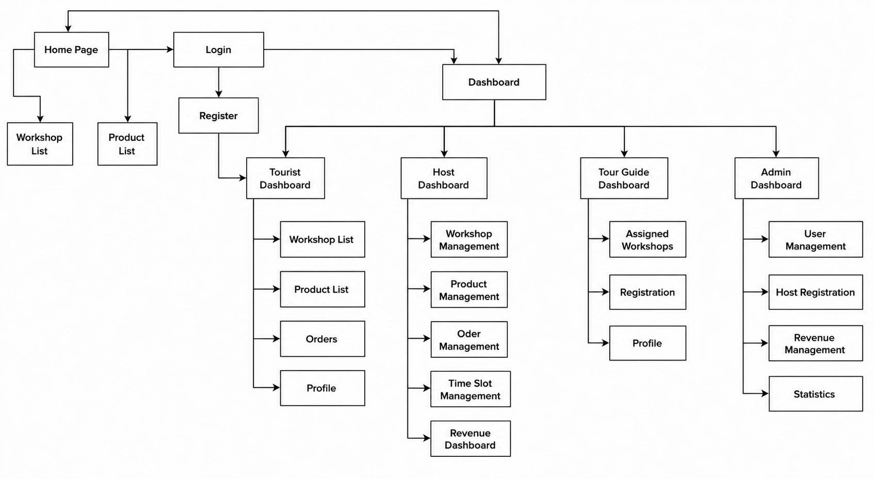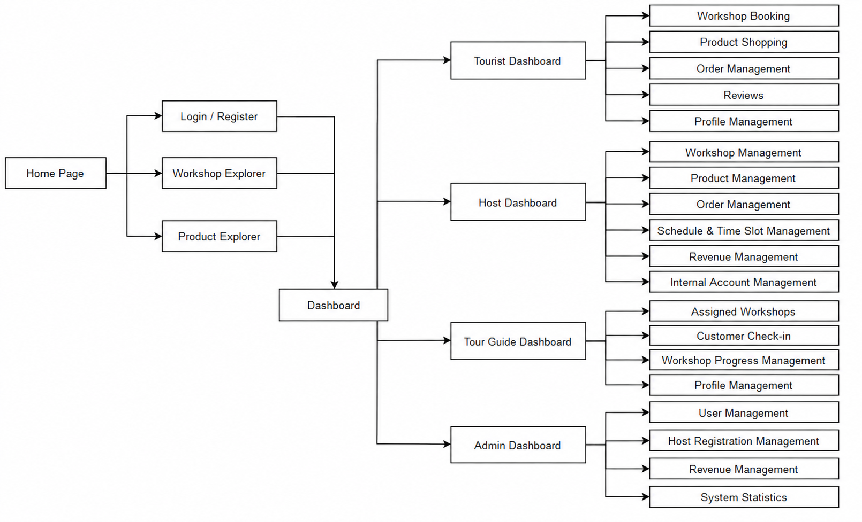

2.2 Screen Descriptions
[Provide the descriptions for the screens in the Screens Flow above]
# | Feature | Screen | Description
1 | Order Meals | Create Order | <<Screen Brief description>>
2 | Order Meals | Change Order
3 | ..

2.3 Screen Authorization
[Provide the system roles authorization to the system features (down to screens, and event to the screen activities if applicable) in the table form as below – replace Role1, Role2,… with your specific system user role names]
Screen | Role-Name1 | Role-Name2 | Role-Name3 | …
<<Screen Name1>> | X |  | X | X
<<Screen Activity>> |  |  | X | X
<<Screen Name2>> | X |  | X
Query All Data | X
Query Own Data |  |  | X
Query Managed Data |  |  | X
Add New Data |  |  | X | X
Update All Data |  |  |  | X
Update Own Data |  |  |  | X
Update Managed Data |  |  |  | X
Delete Data
…

2.4 Non-UI Functions
[Provide the descriptions for the functions which have no UI (or not screens), i.e batch/cron job, service, API, etc.]
# | Feature | System Function | Description
1 | <<Feature Name>> | <<Function Name1>> | <<Function Name1 Description>>
2 | …

3. System High Level Design

3.1 Database Design
[Provide the tables relationship like example below]

a. Database Schema
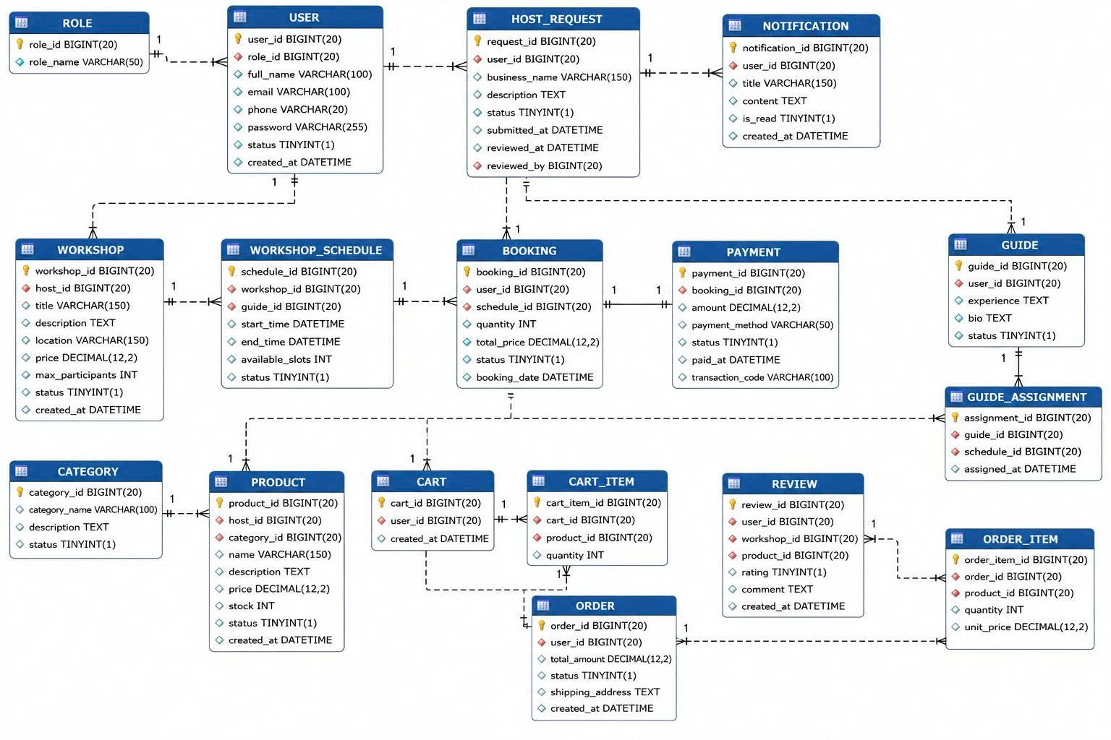

b. Table Descriptions
No | Table | Description
01 | <Table name> | <Description of the table>  - Primary keys: <<list of primary key fields>>  - Foreign keys: <<list of foreign key fields>>
02 | <Table name2> | …

3.2 Code Packages
[Provide the package diagram for each sub-system. The content of this section including the overall package diagram, the explanation, package and class naming conventions in each package. Please see the sample & description table format below]
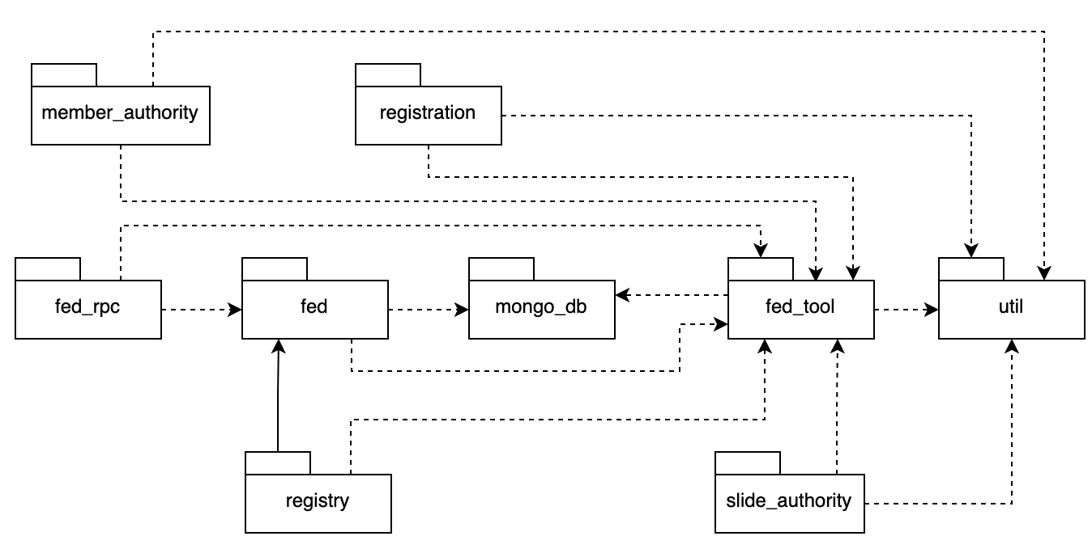
Package descriptions
No | Package | Description
01 | Member_authority | <Description of the package>
02 | registration | <Description of the package>
03 | …

II. Requirement Specifications

1. Patron Feature (Tourist)

1.1 Register / Login Account

a. Functionalities
Provide the functional description for the use cases using the template/guides below
Functional Description Template
UC ID and Name: | UC-1.1 Register / Login Account
Created By: | Nganvm | Date Created: | 31/05/2026
Primary Actor: | Tourist | Secondary Actors:
Trigger: | User clicks "Register" or "Login" button from the homepage, or attempts to access a feature requiring authentication.
Description: | As a Tourist, I want to register a new account or log into the system so that I can book workshops, purchase products, manage bookings, and access personalized services.
Preconditions: | PRE-1: User has not logged into the system. PRE-2: The system is available and accessible.
Postconditions: | POST-1: Tourist successfully logs into the system. POST-2: New account information is stored in the database (registration case). POST-3: Successful login activity is recorded in the Activity Log.
Normal Flow: | Must Have
Alternative Flows:
Exceptions: | BR-1, BR-2, BR-3
Priority: | Must Have
Frequency of Use: | Multiple times per day; expected to have the highest access frequency.
Business Rules: | BR-1, BR-2, BR-3
Other Information: | Support Google Login and Facebook Login.
Assumptions: | User has a valid email address or a Google/Facebook account.

Functional Description Contents
Use Case ID and Name
Give each use case a unique integer sequence number identifier. State a concise name for the use case that indicates the value the use case would provide to some user. Begin with an action verb, followed by an object.
Author and Date Created
Enter the name of the person who initially wrote this use case and the date it was written.
Primary and Secondary Actors
An actor is a person or other entity external to the software system being specified who interacts with the system and performs use cases to accomplish tasks. Different actors often correspond to different user classes, or roles, identified from the customer community that will use the product. Name the primary actor that will be initiating this use case and any other secondary actors who will participate in completing execution of the use case.
Trigger
Identify the business event, system event, or user action that initiates the use case. This trigger alerts the system that it should begin testing the preconditions for the use case so it can judge whether to proceed with execution.
Description
Provide a brief description of the reason for and outcome of this use case, or a high-level description of the sequence of actions and the outcome of executing the use case.
Preconditions
List any activities that must take place, or any conditions that must be true, before the use case can be started. The system must be able to test each precondition. Number each precondition. Example: PRE-1: User’s identity has been authenticated.
Postconditions
Describe the state of the system at the successful conclusion of the use case execution. Label each postcondition in the form POST-X, where X is a sequence number. Example: POST-1: Price of item in the database has been updated with the new value.
Normal Flow - 1.1.0 Register / Login Account
- Tourist accesses the Login/Register page.
- Tourist chooses Login.
- System displays Login Form.
- Tourist enters email and password.
- Tourist clicks "Login".
- System validates the credentials.
- System authenticates the Tourist.
- System records login activity into Activity Log.
- System redirects Tourist to the Home Page or previously requested page.
Alternative Flows
1.1.1 Register New Account
- Tourist clicks "Register".
- System displays Registration Form.
- Tourist enters:
- Full Name
- Email Address
- Password
- Confirm Password
- Tourist submits the form.
- System validates registration information.
- System creates a new account with status "Pending Verification".
- System sends verification email.
- Tourist clicks the verification link.
- System activates the account.
- System redirects Tourist to Login page.
1.1.2 Login with Google
- Tourist clicks "Login with Google".
- System redirects Tourist to Google's authentication page.
- Tourist authenticates using Google account.
- Google confirms authentication.
- System creates or retrieves the Tourist account.
- Return to Step 7 of Normal Flow.
1.1.3 Login with Facebook
- Tourist clicks "Login with Facebook".
- System redirects Tourist to Facebook's authentication page.
- Tourist authenticates using Facebook account.
- Facebook confirms authentication.
- System creates or retrieves the Tourist account.
- Return to Step 7 of Normal Flow.
Exceptions

ID | Description
1.1.0.E1 | Invalid email or password. System displays an error message and allows user to retry.
1.1.0.E2 | Account has not been verified. System requests email verification before login.
1.1.0.E3 | Account is locked or suspended. System displays lock reason and unlock time.
1.1.1.E1 | Registration information is invalid (duplicate email, weak password, invalid email format). System highlights invalid fields and requests correction.
1.1.2.E1 | Google authentication fails. User is returned to Login page.
1.1.3.E1 | Facebook authentication fails. User is returned to Login page.

Priority
Indicate the relative priority of implementing the functionality required to allow this use case to be executed. Use the same priority scheme as that used for the functional requirements.
Frequency of Use
Estimate the number of times this use case will be performed per some appropriate unit of time. This gives an early indicator of throughput, concurrent usage loads, and transaction capacity.
Business Rules
List any business rules that influence this use case. Don’t include the business rule text here, just its identifier so the reader can find it in another repository when needed.
Other Information
Identify any additional requirements, such as quality attributes, for the use case that may need to be addressed during design or implementation. Also list any associated functional requirements that aren’t a direct part of the use case flows but which a developer needs to know about. Describe what should happen if the use case execution fails for some unanticipated or systemic reason (e.g., loss of network connectivity, timeout). If the use case results in a durable state change in a database or the outside world, state whether the change is rolled back, completed correctly, partially completed with a known state, or left in an undetermined state as a result of the exception.
Assumptions
List any assumptions that were made regarding this use case or how it might execute.

b. Business Rules
Provide the business rules those are applied only to the use case
ID | Business Rule | Business Rule Description
FR1 | Password Encoding | User’s password must be encoded with MD5 hashing
FR2 | Invalid Login | User cannot be authenticated if: credentials are incorrect; account is unverified; or account is locked/blocked.
FR3 | Account Locking | After 6 consecutive failed login attempts, the account is locked for 30 minutes

1.2: Manage Personal Profile

a. Functionalities

UC ID and Name: | UC-1.2 Manage Personal Profile
Created By: | Nganvm | Date Created: | 31/05/2026
Primary Actor: | Tourist | Secondary Actors: | None
Trigger: | The tourist selects "My Profile" from the account menu.
Description: | As a Tourist, I want to view and update my profile information and change my password so that my account information remains accurate and secure.
Preconditions: | PRE-1: Tourist is logged into the system.
Postconditions: | POST-1: Updated profile information is saved successfully. POST-2: New password is stored securely if password change occurs.
Normal Flow: | Must Have
Alternative Flows:
Exceptions: | BR-4, BR-5, BR-6
Priority: | Must Have
Frequency of Use: | Medium frequency; users update profile information occasionally.
Business Rules: | BR-1, BR-2, BR-3
Other Information: | Profile picture upload should be supported.
Assumptions: | Tourist owns and manage their own account information.
Normal Flow - 1.2.0 Manage Personal Profile
- Tourists access "My Profile".
- The system displays current profile information.
- Tourists choose to edit their profile.
- Tourist updates one or more fields:
  - Full Name
  - Phone Number
  - Date of Birth
  - Gender
  - Profile Picture
- Tourist clicks "Save Changes".
- The system validates information.
- System updates profile data.
- System displays successful update notification.
Alternative Flows
1.2.1 Change Password
- The tourist selects "Change Password".
- System displays Change Password form.
- Tourist enters:
  - Current Password
  - New Password
  - Confirm Password
- The tourist submits the form.
- The system validates the information.
- The system updates the password.
- The system displays confirmation messages.
1.2.2 Upload Profile Picture
- Tourist selects "Upload Profile Picture".
- The tourist chooses an image file.
- System validates file type and size.
- System uploads and stores the image.
- System updates profile photo.
Exceptions

ID | Description
1.2.0.E1 | Invalid profile information. The system highlights incorrect fields.
1.2.1.E1 | The current password is incorrect.
1.2.1.E2 | New password and confirmation password do not match.
1.2.1.E3 | The new password does not satisfy password policy.
1.2.2.E1 | Uploaded image exceeds size limit or unsupported format.

b. Business Rules
Provide the business rules those are applied only to the use case
ID | Business Rule | Business Rule Description
BR-4 | Profile Ownership | Users may only modify their own profile information.
BR-5 | Password Policy | Passwords must meet minimum security requirements.
BR-6 | Image Validation | Only JPG, PNG, and JPEG files under the specified size limit are accepted.

1.3 Search and View Workshop Details

1.4 Book Workshop

1.5 Pay for Workshop Ticket

1.6 View Electronic Ticket

1.7 Add Product to Cart

1.8 Purchase Product

1.9 Write Review and Upload Photos

2. Common Functions

2.1 UC-2_Login System

a. Functional Description
UC ID and Name: | UC-2_Login System
Created By: | MinhNNT | Date Created: | 16/Jun/2023
Primary Actor: | Customer | Secondary Actors: | None
Trigger: | User clicks Login button from the page header, or  User accesses an authenticated feature (from a link or type the page URL directly into the address bar)
Description: | As a user, I want to be able to log into the system so that I can use the system’s authenticated features and access my personalized account.
Preconditions: | User account has been created & authorized
Postconditions: | - User logs in the system successfully  - The system tracked successful login into the Activity Log
Normal Flow | 2.0 Login System  1. User accesses the User Login screen  2. User types in the login details or choose other login options (see 2.1 and 2.2)  3. User clicks the Login button  4. System validates the login details (see 2.0.E1)  5. System allows user to access  6. System tracks user’s success login to the Activity Log  7. System accesses the Home Page (or the previous calling page if any)
Alternative Flows: | 2.1 Google Login  1. User chooses to login system using Google account  2. System redirects the user to the Google’s Login screen  3. User types in the Google account details and chooses to login  4. Google validates user’s login information successfully and redirect him/her back to the system  5. Return to step 5 of normal flow.  2.2 Facebook Login  1. User chooses to login system using Facebook account  2. System redirects the user to the Facebook’s Login screen  3. User types in the Facebook account details and chooses to login  4. Facebook validates user’s login information successfully and redirect him/her back to the system  5. Return to step 5 of normal flow.
Exceptions: | 2.0.E1 System can’t authenticate the user  1. The Error Message screen is shown to the user  2. User cancels the logging in => UC stops, change to UC-1_View Home Page  3. User clicks “Forgot Password?” link => change to UC-3_Reset Password  4. User clicks “Register” link => change to UC-4_Register User Account
Priority: | Must Have
Frequency of Use:
Business Rules: | FR1, FR2, FR3
Other Information:
Assumptions:

b. Business Rules
ID | Business Rule | Business Rule Description
FR1 | Password Encoding | User’s password must be encoded with MD5 hashing
FR2 | Invalid Logging In | User can’t be authenticated to login the system if below cases  - His/her logging-in details are incorrect  - His/her account has not been verified  - His/her account has been locked or blocked
FR3 | Account Locking | If user inputs wrong logging-in details 6 times continuously, his/her account would be locked in 30 minutes

2.1 Register Host Account

2.2 Login and Manage Workshop Profile

2.3 Manage Workshops

2.4 Manage Timeslots

2.5 Manage Physical Products

2.6 Manage Product Orders

2.7 Assign Tour Guides and Schedules

2.8 Check-in Tourists

2.9 View Workshop Statistics

3. Patron Feature

UC-3.1 Login System

UC-3.2 Manage Personal Profile

UC-3.3 View Assigned Schedule

UC-3.4 Check-in Tourists

UC-3.5 Update Workshop Progress

3.1 UC-5_Order a Meal

a. Functional Description
ID and Name: | UC-5 Order a Meal
Created By: | Prithvi Raj | Date Created: | 10/4/13
Primary Actor: | Patron | Secondary Actors: | Cafeteria Inventory System
Description: | A Patron accesses the Cafeteria Ordering System from the corporate intranet or from home, views the menu for a specific date if desired, selects food items, and places an order for a meal to be delivered to a specified location within a specified 15-minute time window.
Trigger: | A Patron indicates that he wants to order a meal
Preconditions: | PRE-1. Patron is logged into COS.  PRE-2. Patron is registered for meal payments by payroll deduction.
Postconditions: | POST-1. Meal order is stored in COS with a status of “Accepted”.  POST-2. Inventory of available food items is updated to reflect items in this order.  POST-3. Remaining delivery capacity for the requested time window is updated.
Normal Flow: | 5.0 Order a Single Meal  - Patron asks to view menu for a specific date. (see 5.0.E1, 5.0.E2)  - COS displays menu of available food items and the daily special.  - Patron selects one or more food items from menu. (see 5.1)  - Patron indicates that meal order is complete. (see 5.2)  - COS displays ordered menu items, individual prices, and total price, including taxes and delivery charge.  - Patron either confirms meal order (continue normal flow) or requests to modify meal order (return to step 2).  - COS displays available delivery times for the delivery date.  - Patron selects a delivery time and specifies the delivery location.  - Patron specifies payment method.  - COS confirms acceptance of the order.  - COS sends Patron an email message confirming order details, price, and delivery instructions.  - COS stores order, sends food item information to Cafeteria Inventory System, and updates available delivery times.
Alternative Flows: | 5.1 Order multiple identical meals  - Patron requests a specified number of identical meals. (see 5.1.E1)  - Return to step 4 of normal flow.  5.2 Order multiple meals  - Patron asks to order another meal.  - Return to step 1 of normal flow.
Exceptions: | 5.0.E1 Requested date is today and current time is after today’s order cutoff time  1. COS informs Patron that it’s too late to place an order for today.  2a. If Patron cancels the meal ordering process, then COS terminates use case.  2b. Else if Patron requests another date, then COS restarts use case.  5.0.E2 No delivery times left  1. COS informs Patron that no delivery times are available for the meal date.  2a. If Patron cancels the meal ordering process, then COS terminates use case.  2b. Else if Patron requests to pick the order up at the cafeteria, then continue with normal flow, but skip steps 7 and 8.  5.1.E1 Insufficient inventory to fulfill multiple meal order  1. COS informs Patron of the maximum number of identical meals he can order, based on current available inventory.  2a. If Patron modifies number of meals ordered, then Return to step 4 of normal flow.  2b. Else if Patron cancels the meal ordering process, then COS terminates use case.
Priority: | High
Frequency of Use: | Approximately 300 users, average of one usage per day. Peak usage load for this use case is between 9:00 A.M. and 10:00 A.M. local time.
Business Rules: | BR-1, BR-2, BR-3, BR-4, BR-11, BR-12, BR-33
Other Information: | - Patron shall be able to cancel the meal ordering process at any time prior to confirming it.  - Patron shall be able to view all meals he ordered within the previous six months and repeat one of those meals as the new order, provided that all food items are available on the menu for the requested delivery date. (Priority = M)  - The default date is the current date if the Patron is using the system before today’s order cutoff time. Otherwise, the default date is the next day that the cafeteria is open.
Assumptions: | Assume that 15 percent of Patrons will order the daily special (source: previous 6 months of cafeteria data).

b. Business Rules
None

3.2 UC-6_Register for Payroll Deduction

a. Functional Description
ID and Name: | UC-6 Register for Payroll Deduction
Created By: | Nancy Anderson | Date Created: | 9/15/13
Primary Actor: | Patron | Secondary Actors: | Payroll System
Description: | Cafeteria patrons who use the COS and have meals delivered must be registered for payroll deduction. For noncash purchases made through the COS, the cafeteria will issue a payment request to the Payroll System, which will deduct the meal costs from the next scheduled employee payday direct deposit.
Trigger: | Patron requests to register for payroll deduction, or Patron says yes when COS asks if he wants to register
Preconditions: | PRE-1. Patron is logged into COS.
Postconditions: | POST-2. Patron is registered for payroll deduction.
Normal Flow: | 6.0 Register for Payroll Deduction  - COS asks the Payroll System if Patron is eligible to register for payroll deduction.  - Payroll System confirms that Patron is eligible to register for payroll deduction.  - COS asks Patron to confirm his desire to register for payroll deduction.  - If so, COS asks Payroll System to establish payroll deduction for Patron.  - The Payroll System confirms that payroll deduction is established.  - COS informs Patron that payroll deduction is established.
Alternative Flows: | None
Exceptions: | 6.0.E1 Patron is not eligible for payroll deduction  6.0.E2 Patron is already enrolled for payroll deduction
Priority: | High
Business Rules: | BR-86 and BR-88 govern an employee’s eligibility to enroll for payroll deduction.
Other Information: | Expect a high frequency of executing this use case within first 2 weeks after system is released.

b. Business Rules
None

III. Design Specifications

1. <<Feature Name>>

1.1 <<SubFeature Name>>

a. <<Screen/Function Name>>
[Provide brief description of the screen/function + related UC here and other details as in the sub-sections]

UI Design
[This is to describe the UI layout (Mockup prototype) & descriptions for screen fields/components]
<<Mockup prototype>>
Field Name | Field Type | Description
Field Group Name
<<Field-Name>> | <<Field type>> | <<Field description & data initializing design>>

Database Access
[Provide the design description for the screen/function to access the database here: what table the screen/function would access, which transactions does it make (C-Create, R-Read, U-Update, or D-Delete), and how/purpose of the access (by providing Description and SQL commands)]
Table | CRUD | Description
<<Table Name>> | <<transaction(s)>> | <<Table access description: purpose, how,…>>
..

SQL Commands
[Provide the detailed SQL (select, insert, update...) which are used in implementing the screen/function]

1.2 System Access

a. User Login
This screen allows user to be authenticated to the system screens/functionalities.
Related use cases:
- UC02_Login System

UI Design
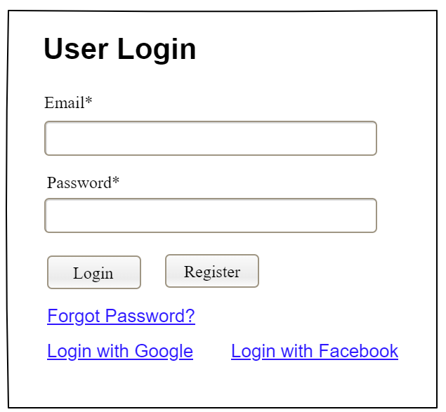

Field Name | Field Type | Description
Email* | Text Box | This is for user to input valid email address for logging in
Password* | Password Box | This is for user to input password for logging in
Login | Button | User clicks to authenticate him/herself into the system with provided email & password
Register | Button | User clicks to redirect to the User Register page for registering new user account to access the system
Forgot Password? | Hyperlink | User clicks to redirect to the Password Reset page for resetting his/her forgot password
Login with Google | Hyperlink | Allow user to login with his/her Google account
Login with Facebook | Hyperlink | Allow user to login with his/her Facebook account

Database Access
Table | CRUD | Description
User | R | Verify UserName & Password information
Setting, User | R | Specify the authorizations of the logged-in user

SQL Commands:
1/ Verify UserName & Password information
SELECT user_id, full_name, email, image_url, status
FROM user WHERE user_name = ? AND password = ?

2/ Specify the authorizations of the logged-in user
SELECT mapped_values FROM setting WHERE setting_id = ?
SELECT setting_name, mapped_values FROM setting WHERE setting_id IN (?)

b. Setting List

UI Design
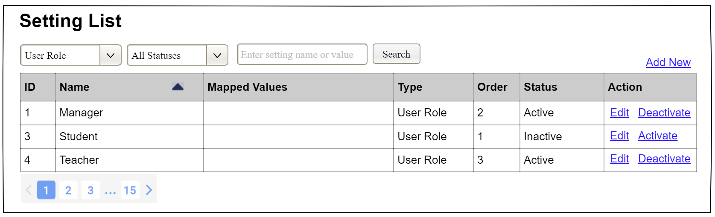

Field Name | Field Type | Description
Search Fields
Setting Type | Combo Box  Single-Choice | Filled with the list of current active setting types  Allow to filter the list by setting type;  Default value is “All Types”
Setting Status | Combo Box  Single-Choice | Values: All Statuses (default), Active, and Inactive  Allow to filter the list by status  Default value: “All Statuses”
Search Phase | Text Box  String (30) | Allow to search using the name or map values  Default value: blank
Search | Button | Click to refresh the list with the defined filter(s) and search phrase.
Add New | Hyperlink | Click to open the Setting Details page for adding new setting (master data)
Data Table
ID | Integer | Auto-increased identifier of the setting
Name | Text | Name of the setting
Mapped Values | Text | Supplementary information for the setting
Type | Text | Type of the setting
Order | Integer | Display order of the setting: the order of the setting type, displayed among the list of settings with the same type
Data Actions
Edit | icon | Click to open the Setting Details page for updating the relevant setting (master data)
Activate | icon | Shown when the data status is inactive. This is to activate the relevant setting (master data)
Deactivate | Ion | Shown when the data status is active. This is to deactivate the relevant setting (master data)

Database Access
Table | CRUD | Description
Setting | RU | Query the list of current settings from the database  Update status of a specific setting

SQL Commands:
1/ Query the list of current settings from the database
SELECT setting_id, setting_name, mapped_values, type_id, display_order, status
FROM setting WHERE (setting_type = ?) AND (status = ?) AND (setting_name LIKE ?)

2/ Update status of a specific setting
UPDATE setting SET status = ? WHERE setting_id = ?

c. Setting Details

UI Design
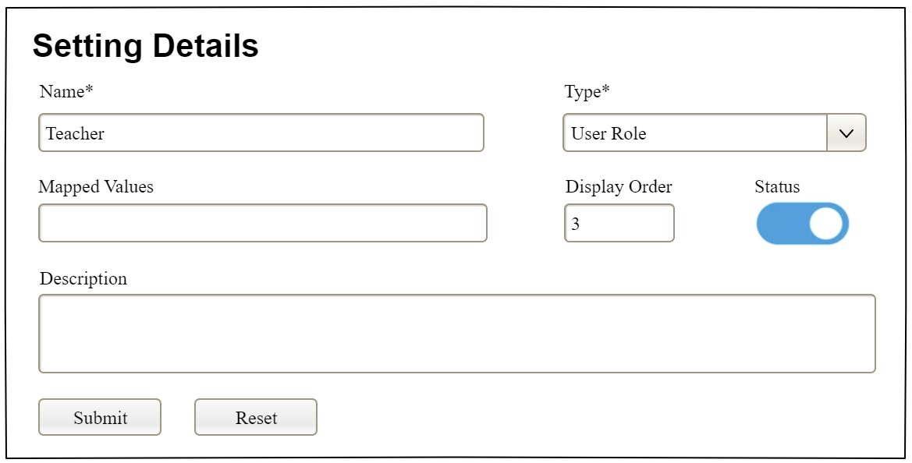

Field Name | Field Type | Description
Name* | Text Box  String (20) | Name of the setting
Type* | Combo Box  (Single Choice) | Type of the setting, filled with the list of setting types  Default value: the first type in the list
Mapped Values | Text Box  String (50) | Supplementary information for the setting (if any)
Order | Text Box  Integer (>=0) | Display order of the setting: the order of the setting type, displayed among the list of settings with the same type
Status | On/Off button | Status of the setting: Active or Inactive  Default value: Active
Description | Text Area  String (200) | Description of the setting
Submit | Button | Click to store new or updated setting details
Reset | Button | Click to reset the changes use has made on the screen fields back to the initial values when the screen is loaded

Database Access
…

IV. Appendix

1. Assumptions & Dependencies
[Record any assumptions that were made when conceiving the project and writing this vision and scope document. Note any major dependencies the project must rely upon for success, such as specific technologies, third-party vendors, development partners, or other business relationships.]
<<Sample:
AS-1: Systems with appropriate user interfaces will be available for cafeteria employees to process the expected volume of meals ordered.
AS-2: Cafeteria staff and vehicles will be available to deliver all meals for specified delivery time slots within 15 minutes of the requested delivery time.
DE-1: If a restaurant has its own on-line ordering system, the Cafeteria Ordering System must be able to communicate with it bi-directionally.
>>

2. Limitations & Exclusions
[Identify any product features or characteristics that a stakeholder might anticipate, but which are not planned to be included in the new product]

3. Business Rules
[Provide common business rules that you must follow. The information can be provided in the table format as the sample below]
<<Sample
ID | Category | Rule Definition
BR-01 | Constraints | Delivery time windows are 15 minutes, beginning on each quarter hour.
BR-02 | Constraints | Deliveries must be completed between 10:00 A.M. and 2:00 P.M. local time, inclusive.
BR-03 | Facts | All meals in a single order must be delivered to the same location.
BR-04 | Facts | All meals in a single order must be paid for by using the same payment method.
BR-11 | Constraints | If an order is to be delivered, the patron must pay by payroll deduction.
BR-12 | Computations | Order price is calculated as the sum of each food item price times the quantity of that food item ordered, plus applicable sales tax, plus a delivery charge if a meal is delivered outside the free delivery zone.
>>

4. ..

